Metabolic Activity Diffusion Imaging [MADI]:
II. Non-Invasive, High-Resolution Human Brain Mapping
of Sodium Pump Flux and Cell Metrics

Charles S. Springer, Jr.,*^{a-e} Eric M. Baker,^{a†} Xin Li,^{a,b†} Brendan Moloney,^{a†} Martin M. Pike,^{a,d†} Gregory J. Wilson,^{f†} Valerie C. Anderson,ª Manoj K. Sammi,ª Mark G. Garzotto,^{g,h} Ryan P. Kopp,^{g,h} Fergus V. Coakley,^{i} William D. Rooney,^{a,d,j} Jeffrey H. Maki^{k}
†These authors, listed in alphabetical order, contributed equally.
ªOregon Health & Science University [OHSU] Advanced Imaging Research Center, ^{b}OHSU Brenden-Colson Center for Pancreatic Care, ^{c}OHSU Knight Cancer Institute, ^{d}OHSU Department of Biomedical Engineering, ^{e}OHSU Department of Chemical Physiology and Biochemistry, ^{f}University of Washington Department of Radiology [current: Bayer Healthcare, Radiology], ^{g}Portland VA Center, Department of Urology, ^{h}OHSU Department of Urology, ^{i}OHSU Department of Radiology, ^{j}OHSU Department of Behavioral Neuroscience, ^{k}University of Colorado Anschutz Medical Center Department of Radiology.

*Corresponding author:
Charles S. Springer, Jr.
Advanced Imaging Research Center, L452
Oregon Health and Science University
3181 S.W. Sam Jackson Park Road
Portland, Oregon 97239
503-418-1531
springer@ohsu.edu

Supplementary Material

Supplementary Material [citations 1-88 in main text]:

S.I. Parameter Extraction.
The molecular displacement and SDE decay library curves are numerically generated. There is no single equation available to calculate them. They each have three variable parameters, k_{io}, ρ, and V. Figure 3 suggests library SDE decays can be sufficient to describe experimental SDE-CT data from essentially any biological tissue. The forward problem seems in hand. Solving the inverse problem – extracting the best parameters for any voxel experimental SDE decay – is difficult. Given the relatively smooth [featureless] decay curves, it is possible very similar curves may have quite different parameter sets. We are most likely facing a clustered parameter space. The discrete libraries may mitigate the “ill-conditioned” inverse problem. A “brute force” [i.e., non-iterative] approach – direct least squares comparison of each voxel decay with all library entries in a grid search (36) – avoids the specific pitfalls of local error surface (89) minima to which gradient descent solvers are prone. The global minimum can still be broad [reflected in Fig. 5c and Table 2]. This method was used for the human brain MADI mapping in Figures 4 and 6, and is now discussed in detail in the Results section.
Though there are analytical [i.e., equation-based] methods for fitting experimental SDE decays, these are all empirical: the parameters cannot be assigned as actual physical properties that might be independently assayed. Furthermore, one or two parameter expressions are insufficient. Gaussian diffusion can be characterized with one parameter, the apparent diffusion coefficient [ADC], in the equation: ln[S(b)/S₀] = e^{-b(ADC)}. However, Gaussian behavior does not obtain for almost any tissue [Fig. 3]. The diffusion kurtosis expressions, Eqs. [2] and [3], have two parameters; D_{ap} and K_{ap}. However, as we indicate in the text, these also are insufficient for many tissue decays.
There have been many demonstrations that three parameter empirical expressions are sufficient to describe experimental SDE decays (87). Perhaps the most popular is the general bi-exponential Equation [S1], where p_{A} is the mole fraction [“population”] of molecules exhibiting diffusion coefficient D_{A},
${S\left(b\right)}/{S_{0}} = p_{A}e^{-bD_{A}}+ \left(1- p_{A}\right)e^{-bD_{B}}$ [S1]
and all other molecules exhibit D_{B}. This expression has three variable parameters: p_{A}, D_{A}, and D_{B}, which are assumed constant [p_{B} = 1 – p_{A}]. It implicitly assumes there is no molecular exchange between the populations [i.e., k_{AB} = 0], which is almost never the case. More importantly however, every realistic tissue diffusion goes through an essentially infinite number of D values (13). The significant hazards of inappropriate empirical bi-exponential interpretations are quite perilous (90). Attempts to assign physical quantities to p_{A}, D_{A}, and D_{B} can lead to very serious errors (8,80,90). These are empirical parameters.
Every SDE-CT library entry is labeled with its set of three physical parameters: k_{io}, ρ, and V. However, each of these decays could be fitted very well with Eq. [S1] and thus also labeled with its set of three empirical parameters: p_{A}, D_{A}, and D_{B}. Voxel experimental decays could be also fitted with Eq. [S1]. The experimental p_{A}D_{A},D_{B} parameter set could be matched with the best library p_{A},D_{A},D_{B} set, using the library as essentially a look-up table. Some weighted sum of the three empirical parameter differences could be used to determine the best match. The latter could then be assigned with its absolute, fundamental parameters: k_{io}, ρ, and V. In this way, k_{io}, ρ, and V parametric aMRI maps could be produced. Such an approach does not seem to us to offer any significant improvement.
The Kärger/Andrasko [KA] model modifies Eq. [S1], with only one additional parameter, to allow steady-state exchange of molecules between populations A and B. This creates in effect an effectively infinite number of exponential terms. This model and its descendants [notably FEXI; filter exchange imaging] are elaborated in the companion paper [(13) S.VII.].

S.II. The Outer Edges of b-Space.
As we indicate in the Discussion section, DWI signals at large b values could be very useful for the inverse problem of extracting aMRI parameters from experimental data. Exploration of ultra-high b-space has been relatively rare in the in vivo DWI literature. However, there has been some. Figure S1a shows three early brain GM studies. Their semi-log b-space SDE decays are re-plotted, and superimposed, in panel a. The red diamonds are from a 1999 rat 63 μL ROI study reaching b_{max} = 64,000 s/(mm)² (62). Important details are listed in Table. S1. The ROI is indicated with the white outline in the upper inset coronal-equivalent image. The green diamonds are from a 2003 rat 125 μL ROI study reaching b_{max} = 580,000 s/(mm)² (60). The ROI is indicated with the white outline in the lower inset image. To achieve this [as far as we are aware] record b_{max}, the investigators employed a SDE-CG acquisition - with a maximum t_{D} of 1177 ms [the 1999 study used the more common SDE-CT approach]. The green diamond decay resembles the Kärger/Andrasko [KA] model large-shutter-speed regime [Ls-sR] condition (8,13,80,91). The black diamonds are from a 2000 human cerebral cortex 3300 μL ROI study reaching b_{max} = 3,800 s/(mm)² (92). It is remarkable how well the decays from these three disparate studies are superimposed – so much so, the black points are hard to discern [we zoom below]. This demonstrates the expected equivalence of SDE-CT and -CG acquisitions at smaller b values (13). The smaller b_{SDE}-value [q²t_{D}] is a rather well-normalized. This is very important, and could be of great use to us. The disparate B₀, G_{max}, δ, and q²_{max} values for these acquisitions are given in Table S1. It is also important to note, the two different rat brain decays
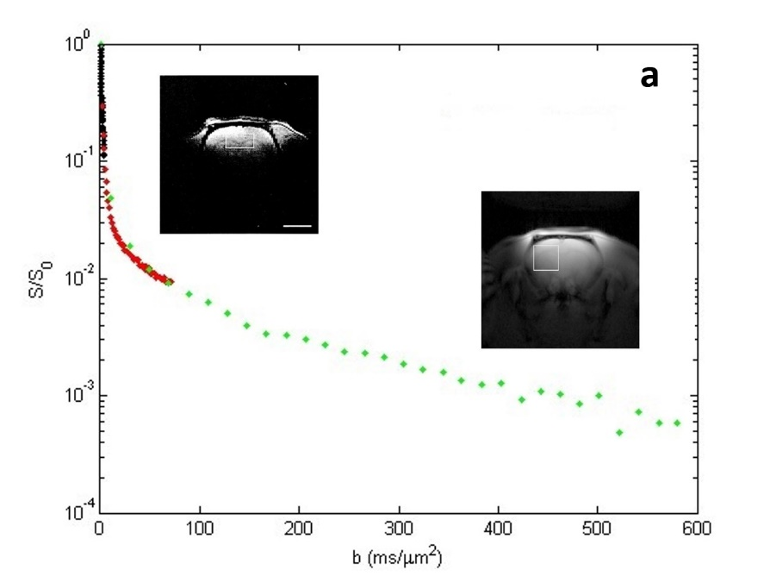
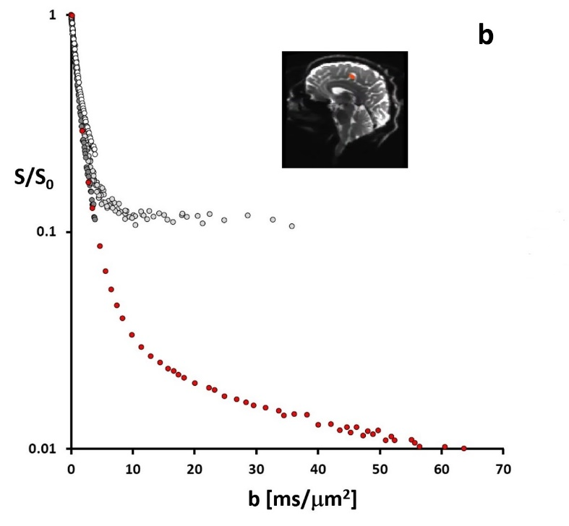
Figure S1. Brain tissue semi-log SDE DWI decays to ultra-large b values; (a) 600,000 s/(mm)², (b) 70,000 s/(mm)². In panel a, the black diamonds are from an ROI in awake, human cerebral cortex (92), the red (62) and green (60) diamonds are from anesthetized rat brain ROIs, which are shown in white frames in the inset images; upper and lower, respectively. The decays are essentially perfectly superimposed, even though the black and red data were acquired with SDE gradient [-CT], while the green data with diffusion time [-CG]-incrementation. The black and red panel a data are zoomed in panel b as dark gray and red circles, respectively. In addition, the white circles are data from a WM ROI in the same human brain (92), while the light gray circles represent SDE-CT data from the left cingulate gyrus of a different awake, resting human brain [red ROI in inset sagittal image] (74). There is meaningful signal [S] at very large b values. For pertinent acquisition parameters, see Table S1.

[red and green points] exhibited essentially identical diffusivity decreases immediately upon sudden death induced in the scanner. Details on this are also found in the companion paper (13).
Panel b zooms two of the panel a decays, and adds two others. The black and red diamonds of panel a are changed to dark gray and red circles, respectively. That is, the dark gray circles arise from the 3300 μL ROI in awake, resting human cerebral cortex GM (92), while the red circles arise from the 63 μL ROI in anesthetized rat brain that is mostly GM (62). Even in this zoomed plot, they are still essentially perfectly superimposed. [Our library matched those human cGM data well (13).] The white circles arise from a 3400 μL white matter [WM] ROI of the same human brain (92). This illustrates a typical difference for brain cGM and WM decays. The latter have smaller diffusivity. The light gray circles in Fig. A10b arise from a 220 μL ROI in the awake, resting human left cingulate gyrus. This is from a more recent SDE-CT study; most likely the record human brain b_{max}, almost 40,000 s/(mm)² [Table S1], using a specially designed connectome human brain PFG coil array (74). This ROI [red in the inset sagittal image slice] most likely contains both GM and WM, and the decay splits those of the dark gray and white circles.
These studies are very important. They show there is still meaningful brain signal [3 - 20% of S₀] at b = 10,000 s/(mm)². Moreover, Fig. 3 suggests most biological tissues have diffusivities smaller than that of brain GM, and thus even greater signal at any given b value. There would be, of course, even more signal at 7,000 s/(mm)². Together, the Fig. S1 results further suggest such a b value could be reached with either SDE-CT or -CG [green diamonds, panel a] acquisitions. For clinical scanners, 7,000 s/(mm)² may be achievable with SDE-CT. Larger b values may require SDE-CG – or a hybrid CG/CT method. For the SMS 3T instrument we employed for the SDE-CT brain aMRI maps [Fig. 4], b = 7,000 s/(mm)² requires t_{Dmax} of only 44 ms [compared with the ~36 ms we used]. Our current d^{rms} time-course library [t_{RW,max} = 80 ms] (13) can facilitate SDE-CT decay simulations out to b_{max} = 8000 s/(mm)² [= q²_{max}t_{D} = (10⁵ (mm)⁻²)(8x10⁻² (s))]. And, our library SDE decays are simulation artifact-free down to S ≤ 0.015 S₀ [1.5%]. Matching high b_{max} data could produce more precise k_{io}, ρ, and V maps.
The Fig. S1a green SDE-CG decay merits further discussion. The authors (60) asserted this plot reveals the trans-cytolemmal water exchange system to be in the KA model Ls-sL [formerly, SXL] condition (8,13). That is: [q²ΔD =] κ_{Dio} >> k [= k_{io} + k_{oi}]. The q² value 0.49 (μm)⁻² [Table S1] is sufficient to achieve this. This KA condition is qualitatively different from all others, which cannot be analytically solved (13). In an SDE-CG decay, the abscissa essentially represents t_{D} [b ∝ t_{D}]. When t_{D} becomes sufficient that the ¹H₂O_{o} coherence has dissipated, the decay slope becomes –k_{io} (13). The decay is no longer diffusion-limited, but efflux-limited. This is a natural decay articulation; a non-Gaussian/pseudo-Gaussian switchover [a non-linear/linear switchover in the semi-log plot]. The cellular efflux rate constant can then be determined directly from the now-linear decay. From the green decay limiting slope, Leibfritz and co-workers determined k_{io} = 1.61 (±0.08) s⁻¹ for anesthetized rat brain GM [n = 3] (60). This is the most precise early brain k_{io} measurement, and is in excellent agreement with other [less precise] GM model determinations [Table 3]. However, all these literature reports still used 2SX shutter-speed analyses. Difficulties with these are discussed in (13) S.VII.
When Gruetter and co-workers made the same assumption for their Fig. S1a red SDE-CT decay, they obtained k_{io} = 8.55 (±0.30) s⁻¹ for anesthetized rat brain GM (62). As shown in Table 3, this disagrees with the other GM model measurements. This is likely because of either: a.) their acquisition is SDE-CT, or b.) their b_{max} is only 70,000 s/(mm)² [Table S1]. If it is the latter, this means the SDE-CG switchover occurs at b > 70,000 s/(mm)² for anesthetized rat brain GM. If we could achieve the Ls-sL condition [i.e., reach the switchover] with a clinical instrument, we could apply SDE-CG diffusion encoding to the entries in our molecular displacement [d^{rms}] library (13).

S.III. References found only in SM.

- Li X, Cai Y, Moloney B, Chen Y, Huang W, Woods M, Coakley FV, Rooney WD, Garzotto MG, Springer CS. Relative sensitivities of DCE-MRI pharmacokinetic parameters to arterial input function (AIF) scaling. J. Magn. Reson. 2016;269:104-112.
- Mulkern RV, Balasubramanian M, Maier SE. On the perils of multiexponential fitting of diffusion MR data. J. Magn. Reson. Imag. 2017;45:1545-1547.
- Hills BP, Godward J, Manning CE, Biechlin JL, Wright KM. Microstructural characterization of starch systems by NMR relaxation and Q-space microscopy,” Magn. Reson. Imag. 1998;16:557-564.
- Clark CA, Le Bihan D. Water diffusion compartmentation and anisotropy at high b values in the human brain. Magn. Reson. Med. 2000;44:852-859.
- Huang SY, Tobyne SM, Nummenmaa A, Witzel T, Wald LL, McNab JA, Klawiter EC. Characterization of axonal disease in patients with multiple sclerosis using high-gradient-diffusion MR imaging. Radiology 2016;280:244-251.

S.IV. Acronyms and Symbols.

A cell surface area
ADC apparent diffusion coefficient
ATP adenosine triphosphate
A/V cell area/volume [claustrophobia] ratio
AWC active trans-membrane water cycling
AXR apparent exchange rate
a_{e} membrane “concentration” parameter
aMRI activity MRI
argκ_{Xio} s-s argument
α_{i} contracted Voronoi cell i annulus width
α* global α target
α_{i}* target α_{i}
α_{i}^{(lim)} α_{i} upper limit
α′ perpendicular distance to gap center
BBB blood-brain-barrier
B₀ main magnetic field
b acquisition diffusion-encoding potential
CA contrast agent
CA_{o} extracellular CA
[CA_{o}] CA_{o} concentration
CG constant G, t_{D} incrementation
CI confidence interval
CT constant t_{D}, G incrementation
CXC constant exchange condition
$C_{i}$ standard Voronoi cell i
$C_{i}^{(cell)}$inner contracted Voronoi cell i
$C_{i}^{\left(ann\right)}$annulus of $C_{i}^{(cell)}$
c_{i} seed point of $C_{i}$
γ proton gyromagnetic ratio
D diffusion coefficient [DT magnitude]
D_{A} intrinsic water D in compartment A
D′_{A} apparent D_{A}
D_{ap} apparent D from Kurtosis Equation
D_{B} intrinsic water D in compartment B
D′_{B} apparent D_{B}
D diffusion tensor
DCE dynamic-contrast-enhanced
DTI diffusion tensor imaging
DWI diffusion-weighted imaging
D-w diffusion-weighted
D_{in} intracellular water D [no exchange]
D′_{in} apparent D_{in}
D_{n} nanoscopic D
D_{out} extracellular water D [no exchange]
D′_{out} apparent D_{out}
D_{WM} D_{in} or D_{out} limit at large t_{RW}
D₀ pure water diffusion coefficient [37ºC]
|ΔD| absolute D_{in}, D_{out} difference
d diffusional water molecule displacement
d^{rms} root-mean-square of d
ECV tissue extracellular volume fraction [v_{e}]
δ PFG duration
Δ diffusion interval
Δ_{ap} apparent Δ
E expectation
FDG 2-deoxy-2-¹⁸Fluoro-D-glucose
FEXI filter exchange imaging
FOV field-of-view
FWHM full width at half maximum
FXL fast-exchange-limit
fL [(μm)³]
fMRI functional MRI
f_{M} intracellular macromolecular v
$\hat{Φ}$ subset of seeds
φ spin precessional phase
G magnetic field gradient tensor
G G magnitude
GLUT glucose transporter
GM cerebral gray matter
Γ gamma distribution
HPC high power computing
H₂O_{free} pure water
H₂O_{in} intracellular water
H₂O_{out} extracellular water
[H₂O_{i}] H₂O_{in} concentration, 0.042 nmol/pL
¹H₂O water proton MR signal
IF isotropic fractionation
IVIM intra-vascular incoherent motion
KA Kärger/Andrasko
K_{ap} apparent Kurtosis coefficient
k steady-state water exchange rate constant
k_{AB} unidirectional water rate constant, A→B
k_{io} cellular water efflux k (1/τ_{i})
k_{io}(a) active k_{io} contribution
k_{io}(p) passive k_{io} contribution
k_{oi} cellular water influx k
k_{pe} capillary CA efflux k
k_{po} capillary water efflux k
K_{o}⁺ extracellular potassium ion
K-Ras Kirsten rat sarcoma virus oncogene
κ fraction of α
к_{Dio} diffusigraphic s-s
к_{Fio} flow s-s
κ_{Xio} [X = D, F, 1]
к_{1io} longitudinal s-s
Ls-sL large κ_{Xio} limit [formerly, SXL] condition
Ls-sR large κ_{Xio} regime [formerly, SXR] condition
l_{s} RW step length
l_{s}^{rms} root-mean-square l_{s}
M_{enc} PFG [zeroth] moment
MR magnetic resonance
MRI MR imaging
^{c}MR_{enz} cellular metabolic rate for enzyme process = ^{t}MR/ρ
^{t}MR_{enz} tissue metabolic rate for enzyme process = ρ^{c}MR
m number of membranes crossed in RW step
N number of samples
NA normal-appearing
NKA Na⁺,K⁺-ATPase (sodium pump)
NXL no-exchange-limit
n number of seed points
oxphos oxidative phosphorylation
Ω domain of Voronoi cells
Ω_{pop} populated [encompassing] Ω
Ω_{sim} simulation Ω
Ω_{src} source Ω
ω spin precessional [angular] frequency
PET positron emission tomography
PFG pulsed G
PVA partial volume averaging
P(n) probability of finding n seed points in Ω
p tissue mole fraction (“population”)
p′ apparent p
p′_{A} apparent p of water in compartment A
p′_{B} apparent p of water in compartment B
p_{p} water molecule permeation probability
pL [1000 (μm)³]
P_{W} membrane water permeability coefficient
P_{W}† capillary water permeability coefficient
P_{W}(a) active cytolemmal P_{W} contribution
P_{W}(p) passive cytolemmal P_{W} contribution
q PFG wave number [spatial frequency]
RF radio frequency
ROI region-of-interest
RW random walk
R₁ longitudinal relaxation rate constant
R_{1i} intrinsic ¹H₂O_{i} R₁
R_{1o} intrinsic ¹H₂O_{o} R₁
R_{1o0} R_{1o} in the absence of CA_{o}
r water molecule position after RW
r₀ starting water molecule position
r₁ longitudinal relaxivity
r_{1o} CA_{o} r₁
ρ cell (number) density
(ρV)′ apparent ρV product
S tissue ¹H₂O transverse signal strength
S(b) S at b
S₀ Boltzmann S
S† capillary surface area per unit tissue
SD standard deviation [σ]
SDE single diffusion encoding
SE standard error [σ/(√N)]
SGLT sodium/glucose co-transporter
SMS Siemens Medical Systems
S/N signal to noise ratio
Ss-sR small κ_{Xio} regime [formerly, FXR] condition
SXL slow-exchange-limit
SXR slow-exchange-regime
s-s trans-cytolemmal MR shutter-speed (к_{Xio})
T Tesla
TE pulse sequence magnetization echo time
TI pulse sequence inversion time
TR pulse sequence repetition time
Tr[D] trace of D
TT total acquisition time
T₁ longitudinal relaxation time constant
T₁-w T₁-weighted
T₂ transverse relaxation time constant
t_{D} diffusion time
t_{RW} RW duration
t_{V} t_{D} when κ_{Dio} vanishes
t_{WM} t_{D} when the “well-mixed” condition is met
t_{s} RW step time
τ_{i} mean H₂O_{i} molecule lifetime (1/k_{io})
V cell volume
V(Ω) Ω volume
Vs-s vanished s-s (formerly, FXL) condition
VXC varying exchange condition
v tissue volume fraction
v_{b} blood volume fraction
v_{e} ECV
v_{i} intracellular v [ρV]
WM cerebral white matter
x water cycling stoichiometry [H₂O/ATP]
x′ x for individual water co-transporter
x position of random walking molecule
x_{k} x after RW step k
[X_{i}] intracellular X concentration
[X_{o}] extracellular X concentration
[X_{t}] tissue X concentration
⟨X⟩ ROI- or voxel-average of X
2SX two-site-exchange
3S2X three-site-two-exchange

Table S1. Large b-Value Brain Literature Studies
brain | B₀ [T] | ROI [μL] | b_{max} [s/(mm)²] | SDE | G_{max} [mT/m] | δ  [ms] | t_{Dmax} [ms] | q²_{max}  [(μm)⁻²] | TT [min] | Ref.
rat | 9.4 | 63 | 70,000 | CT | 300 | 14 | 110 | 0.38 |  | (62)
rat | 4.7 | 125 | 580,000 | CG | 151 | 10 | 1177 | 0.49 |  | (60)
human | 1.5 | 3300 | 3,800 | CT | 40 | 151 | 2.7 | 0.07 | 9 | (92)
human | 3.0 | 220 | 37,000* | CT | 293 | 8.7 | 117 | 0.01* |  | (74)
*These values are erroneously under-reported in (74). They are herein corrected – in consultation with the authors. For the correct q_{max}, see (93).

